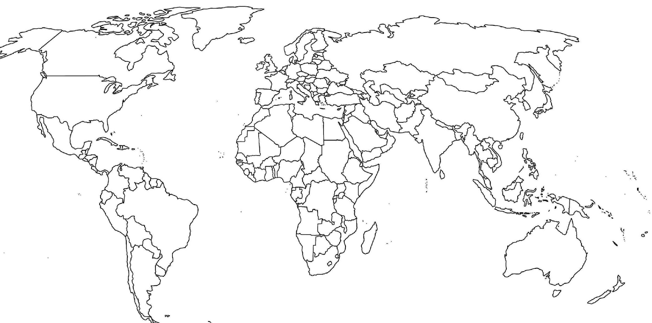
TITLE:_____________________________________ NAME:_______________

Top 10 Liveable Cities (2021) |  | Bottom 10 Liveable Cities (2021)
1. | 6. | 1. | 6.
2. | 7. | 2. | 7.
3. | 8. | 3. | 8.
4. | 9. | 4. | 9.
5. | 10. | 5. | 10.

